**Part 7 – Solving Quadratic Equations**

**Example.** Find all real solutions for the equation

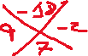

**Example.**



**Example.** Find all real solutions for the equation



**Example.** Find all real solutions for the equation

